Practical no. 23
Name :- Danish Altaf Solkar Enrolment no. :-24111590805
Class :- CO3K – B Subject :- OOP
Aim :- Write a program which open a file read and write mode and display the content on output screen using open().
Program :-
#include <iostream.h>
#include <conio.h>
#include <fstream.h>
void main()
{
clrscr();
fstream file("sample.txt", ios::in | ios::out);
if (!file)
{
cout << "File could not be opened!";
getch();
return;
}
char ch;
cout << "Contents of file:\n";
while (file.get(ch))
cout << ch;
file.clear();
file.seekp(0, ios::end);
cout << "\n\nEnter text to append (end with #):\n";
while (cin.get(ch) && ch != '#')
file.put(ch);
file.close();
cout << "\n\nUpdated file content:\n";
file.open("sample.txt", ios::in);
while (file.get(ch))
cout << ch;
file.close();
getch();
}
Output :-
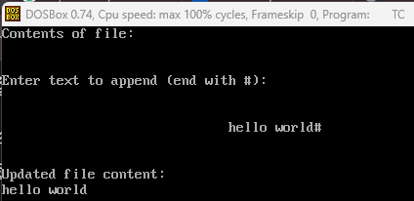

Aim :- Write a program which open a file read and write mode and display the content on output screen using constructor.
Program :-
#include <iostream.h>
#include <fstream.h>
#include <conio.h>
class FileHandler
{
fstream file;
public:
FileHandler(const char *fname)
{
file.open(fname, ios::in | ios::out);
if (!file)
{
cout << "File could not be opened!";
return;
}
char ch;
cout << "Contents of file:\n";
while (file.get(ch))
cout << ch;
file.clear();
file.seekp(0, ios::end);
cout << "\n\nEnter text to append (end with #):\n";
cin.get(ch);
while (ch != '#')
{
file.put(ch);
cin.get(ch);
}
file.close();
cout << "\n\nUpdated file content:\n";
file.open(fname, ios::in);
while (file.get(ch))
cout << ch;
file.close();
}
};
void main()
{
clrscr();
FileHandler f("sample.txt");
getch();
}
Output :-
